

Foundations of Programming
Assignment No. : 12

PROBLEM STATEMENT:
Write a program in C to accept two numbers from the user and compute:
- The smallest common divisor of the two numbers (other than 1, if any)
- The Greatest Common Divisor (GCD) of the two numbers

OBJECTIVE:
• To understand the use of mathematical operations in C.
• To implement loops and conditional statements
. • To perform number-based computations.
• To enhance logical thinking using menu-driven programs.

THEORY:
Divisors and the Greatest Common Divisor (GCD) are fundamental concepts in number theory. The smallest common divisor of two numbers is the smallest positive integer greater than 1 that divides both numbers. The GCD of two numbers is the largest positive integer that divides both numbers without leaving a remainder. In C programming, these operations can be efficiently implemented using loops and the Euclidean algorithm, which repeatedly applies the modulo operation until the remainder becomes zero.

PLATFORM:
Linux

ALGORITHM:
1: Start

2: Read and input 2 numbers from user.

3: Calculate minimum of both members

4: Initialize i1 = 2

5: Initialize Greatest Common Divisor as gcd = 1

6. Initialize Least Common Divisor as scd = 1

7: Loop i1 from 2 to minimum,

if ((a % i1 == 0) && (b % i1 == 0)){
scd = i1
break
}

8: Print Least Common Divisor as scd.

9: Initialize i2 = min

10: Loop i2 from minimum to 1,

if ((a % i2 == 0) && (b % i2 == 0)){
gcd = i2
break
}

11: Print Greatest Common Divisor as gcd.

12: Stop

FLOWCHART:

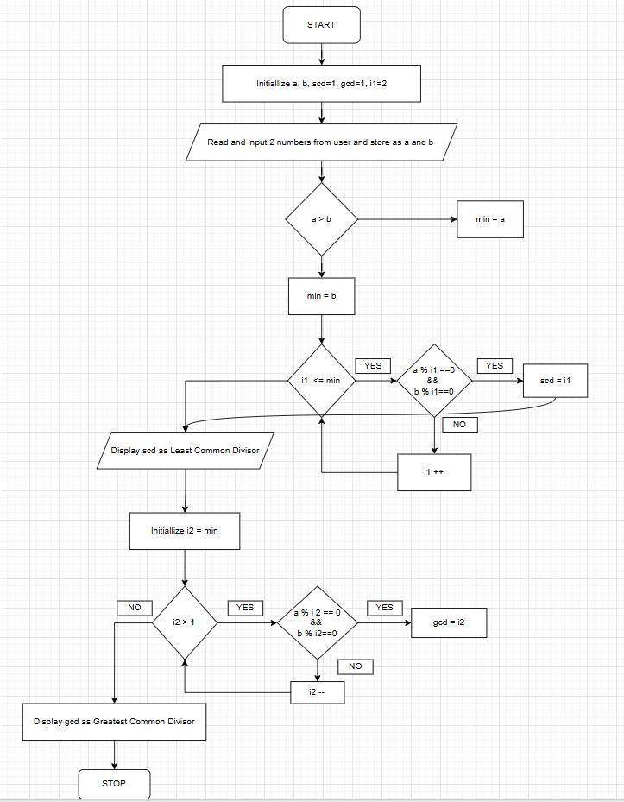

C PROGRAM:
#include <stdio.h>
int main() {
int a,b,scd=1,gcd=1;
printf("Enter 2 numbers :");
scanf("%d%d",&a,&b);
int max,min;
if(a>b){
max=a;
min=b;
}
else{
max=b;
min=a;
}
int i1=2;
while(i1<=min){
if(a%i1==0 && b%i1==0){
scd=i1;
break;
}
i1++;
}
printf("Least Common Divisor : %d\n",scd);
int i2=min;
while(i2>1){
if(a%i2==0 && b%i2==0){
gcd=i2;
break;
}
i2--;
}
printf("Greatest Common Divisor : %d\n",gcd);
return 0;
}

INPUT:
The user enters two integer numbers.
Example Input: Number 1: 24 Number 2: 36

OUTPUT:
The program displays the smallest common divisor and the GCD of the two numbers.
Example Output: Smallest Common Divisor: 2 Greatest Common Divisor (GCD): 12

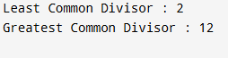

CONCLUSION:
Thus, the program to find the smallest common divisor and the Greatest Common Divisor of two numbers was successfully implemented using C programming. This program demonstrates the use of loops, conditional statements, and the Euclidean algorithm.

FAQs:
- What is meant by the Greatest Common Divisor (GCD)?
- Why does the Euclidean algorithm efficiently compute the GCD?
- How can this program be modified to handle negative numbers?
- What changes are required to compute the Least Common Multiple (LCM) using the GCD?
- How can this program be extended to find the LCM of two numbers?

